جامعة المنوفية
كلية الحاسبات والمعلومات
2024-2025
Menofyia University
System Analysis & design Project
second year
2024-2025


No. | Name | Section
1 |  | 3
2 |  | 3
3 |  | 4
4 |  | 5
5 |  | 7
6

Online Donation Platform

Planning (Project Plan)

Project Identification
Project Name:
Online Donation Platform

Current Problem:
- Donors can't easily find trusted charities and real cases to support
- Donations are collected through scattered and manual channels
- difficulty of tracking donations and how they are spent
- possibility of fraud through fake fundraising campaigns

Description about project:
- The system is a website that helps donors find the cause they want easily by entering the campaign name or code, it enables the user to donate to any campaign he wants using multiple payment methods. System works to organize campaigns in a specific way such as by category (health, education, food, shelter) or by urgency, the system can track the amount collected for each campaign by its code. Ease of tracking donations faster, less effort and without errors, it can be kept from fraud and misuse by verifying charities and sending donors a receipt and updates about how their money was spent. The platform contains all types of causes in different fields.

System Request
System Request—Online Donation Platform
Project Sponsor: | Charity Foundation Director
Business Need: | - Reduce fraud and fake fundraising campaigns.  - Dispense with paper and cash collection.  - Make donating available to everyone.  - Make donating available all the time.
Business Requirements: | 1- Update system.  2- Provide on-line access.  3- IT unit.  4- Secure payment gateway.
Business Value: | 1- Providing transparent information.  2- Saving time.  3- Saving cost.  4- Increasing donations.
Special Issues or Constraints: | 1- Deadline in 1 January.  2- Constantly updating campaign data.

Feasibility Analysis
Technical Feasibility
  - We need to design it using Css or java script or html
  - We need some applications also to make it like visual studio
  - We need to make it work online when you are connected to the internet
  - We need to add a secure payment gateway and make the website work on windows or android
Economic Feasibility
  - The benefit of this project will be acceptable
  - The cost of this project will come from payment gateway fees only but it will not be so harmful
  - The only requirement to donate is a credit card or e-wallet
  - The cost of the developing will not be many
Organizational Feasibility
Organizational Feasibility Analysis includes the assessment of:
- Management prowess: what is the ability of the initial management team?
- Resource sufficiency: what nonfinancial resources such as human resources (management, employees), facilities/location, equipment, intellectual property protection, etc. are required?
Methodology

Chosen methodology
The project follows the Structured System Development Life Cycle (SDLC) using the Waterfall approach. The requirements of the Online Donation Platform (donor registration, campaigns, secure payment, receipts and reports) are clear from the beginning, and each phase ends with a documented output that is reviewed before the next phase starts.
Project phases
1- Planning: project identification, system request, feasibility analysis, time estimation, and task plan (PERT and Gantt charts).
2- Analysis: interviews with charity managers, questionnaire for donors, data flow diagrams, data dictionary, and process specifications.
3- Design: entity relationship diagram, normalization, database design, screens for donors, charities and admin, and payment security design.
4- Implementation: coding the website (HTML, CSS, JavaScript and database), testing, deployment, and training of the users.
Why this methodology
- Clear and ordered phases that are easy to follow.
- Every phase has deliverables and documents for the team.
- Progress and time can be tracked easily using PERT and Gantt charts.
- Suitable for a team project with fixed deadline (1 January).
Time Estimation

 | Planning | Analysis | Design | Implementation
Standard percentages | 15% | 20% | 35% | 30%
Estimated time based on planning time | Actual: 12 days | 16 days | 28 days | 24 days

Project schedule (the project is finished before the deadline on 1 January):
Phase | Percentage | Duration | Start Date | End Date
Planning | 15% | 12 days | 12 Oct 2026 | 23 Oct 2026
Analysis | 20% | 16 days | 24 Oct 2026 | 08 Nov 2026
Design | 35% | 28 days | 09 Nov 2026 | 06 Dec 2026
Implementation | 30% | 24 days | 07 Dec 2026 | 30 Dec 2026
Total | 100% | 80 days | 12 Oct 2026 | 30 Dec 2026

Case Study

Hope Charity Foundation
Hope Charity Foundation is a small non-profit organization that supports families in need by providing food, medical treatment and school fees. It depends on donations from individuals and companies.
Current situation and problems
- Donations are received as cash, bank transfers and social media messages, and are recorded manually in paper registers and spreadsheets.
- Donors cannot find the cases they want to support easily, and they do not know how their money is spent.
- Counting and reporting the donations takes a long time and has many errors.
- Fake campaigns that use the name of the foundation make donors lose trust.
Proposed solution
The Online Donation Platform lets donors search for verified campaigns by name, code or category, donate in a few clicks using a credit card or e-wallet, receive an electronic receipt, and follow the progress of the campaign. Charity managers add and update campaigns, and the admin verifies charities and gets daily reports.
Expected results
- Donations are available 24 hours a day for everyone.
- Less time and effort in registering and reporting donations.
- More transparency, less fraud, and higher trust of donors.

PERT Chart
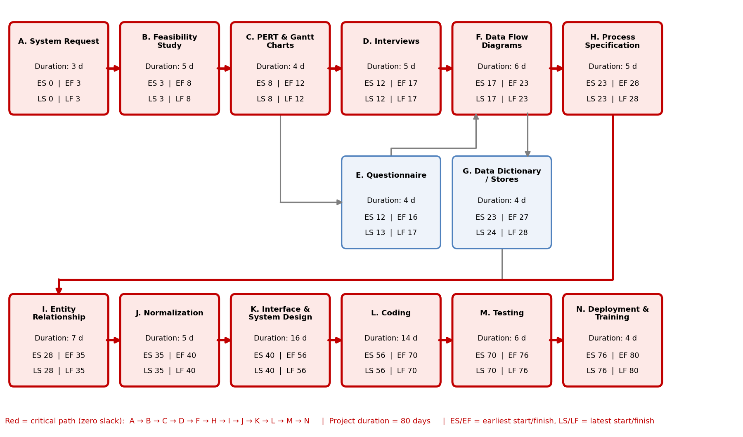
Gantt Chart
